|  |
| --- |
| **A**  **PROJECT REPORT ON** |
|  |
|  |
| Clinic Management System |
|  |
|  |
| SUBMITTED IN  PARTIAL FULFILLMENT OF  **DIPLOMA IN MOBLIE COMPUTING (PG-DMC)** |
|  |
|  |
|  |
|  |
|  |
|  |
|  |
| **BY**  **Gaurav Bora** |
|  |
|  |
| **UNDER THE GUIDENCE OF**  **Manjusha Nikam** |
|  |
|  |
|  |
| **AT**  **SUNBEAM INSTITUTE OF INFORMATION TECHNOLOGY,**  **PUNE** |

|  |  |  |  |
| --- | --- | --- | --- |
| **SUNBEAM INSTITUTE OF INFORMATION TECHNOLOGY,**  **PUNE.** | | | |
|  | | | |
|  | | | |
|  | | | |
|  | | | |
| **CERTIFICATE** | | | |
|  | | | |
| This is to certify that the project | | | |
|  | | | |
| Clinic Management System | | | |
|  | | | |
| Has been submitted by | | | |
|  | | | |
| **Gaurav Bora** | | | |
|  | | | |
|  | | | |
| In partial fulfillment of the requirement for the Course of **PG Diploma in Mobile Computing (PG-DMC March 2023)** as prescribed by The **CDAC** ACTS, PUNE. | | | |
|  | | | |
|  | | | |
| Place: Pune | | | Date: 1-September-2023 |
|  | | | |
|  | | | |
|  | | | |
|  | | | |
|  | | | |
|  | | | **Manjusha Nikam** |
|  | | | **Project Guide** |
|  |  |  |  |

**ACKNOWLEDGEMENT**

I would like to express my special thanks of gratitude to my teacher Manjusha Nikam as well as our Director Nitin Khudale who gave me the golden opportunity to do this wonderful project on the topic Clinic Management System which also helped me in doing a lot of Research and I came to know about so many new things I am really thankful to them.

Gaurav Bora

**ABSTRACT**

Multi-Platform Application that will track user’s daily life stats and let the user see how well he/she doing. Application will get data from sensor and user can also put data manually all this data is supposed to be synced with server and stored in data base. A website of same application will allow user to see details in very informatic manner

|  |  |  |
| --- | --- | --- |
|  | **INTRODUCTION** | 1 |
|  | 1.1 Introduction | 2 |
|  | **Product Overview and Summary** |  |
|  | 2.1 Purpose |  |
|  | 2.2 Scope |  |
|  | 2.3 User Classes and Characteristics |  |
|  | 2.4 Design and Implementation Constraints |  |
|  | **REQUIREMENTS** |  |
|  | 3.1 Functional Requirements |  |
|  | 3.1.1 Use case for Administrator. |  |
|  | 3.1.2 Use case for User. |  |
|  | 3.2 Non - Functional Requirements |  |
|  | 3.2.1 Usability Requirement |  |
|  | 3.2.2 Performance Requirement |  |
|  | 3.2.3 Reliability Requirement |  |
|  | 3.2.4 Portability Requirement |  |
|  | 3.2.5 Security Techniques |  |
|  | **PROJECT DESIGN** |  |
|  | 4.1 Data Model |  |
|  | 4.1.1 Database Design |  |
|  | 4.2 Process Model |  |
|  | 4.2.1 Functional Decomposition Diagram |  |
|  | 4.2.2 Data Flow Diagram (DFD) |  |
|  | **PROJECT RELATED STATISTICS** |  |
|  | **CONCLUSION** |  |

**INDEX**

**LIST OF TABLES**

|  |  |  |
| --- | --- | --- |
| **Section** | **Table Title** | **Page** |
| **Fig 3** | **Complete Database** |  |
|  |  |  |
|  |  |  |
|  |  |  |
|  |  |  |
|  |  |  |

**LIST OF FIGURES**

|  |  |  |
| --- | --- | --- |
| **Section** | **Figure Title** | **Page** |
| **Fig 1-2** | **User & Admin Use Case Diagram** |  |
| **Fig 3** | **Data Flow Diagram** |  |
| **Fig 4 -9** | **Dashboard Screen Shots** |  |
| **Fig 10-13** | **Mobile Application Screen Shots** |  |
|  |  |  |
|  |  |  |
|  |  |  |
|  |  |  |
|  |  |  |
|  |  |  |
|  |  |  |
|  |  |  |

**INTRODUCTION**

In today's rapidly evolving healthcare landscape, efficient and organized clinic management is essential to provide quality patient care, streamline administrative processes, and ensure optimal resource utilization. A Clinic Management System (CMS) plays a pivotal role in achieving these goals by integrating various functions within a medical facility, ranging from patient registration and appointment scheduling to billing, electronic health records (EHR) management, and more. This report delves into the significance of a Clinic Management System, its key components, benefits, challenges in implementation, and its potential to transform healthcare delivery.

**The goal of this project:** The primary goal of the Clinic Management System (CMS) project is to enhance the efficiency, effectiveness, and quality of healthcare services within a clinic or medical facility. The project aims to achieve this overarching goal through the implementation of a comprehensive and integrated software solution that streamlines various administrative, operational, and clinical processes. By leveraging technology and automation, the CMS project seeks to address specific objectives that contribute to improved patient care and optimized clinic management

**Product Overview and Summary**

**| Purpose:** The Clinic Management System (CMS) serves a multifaceted purpose aimed at improving the overall efficiency, effectiveness, and quality of healthcare services within a clinic or medical facility. This purpose encompasses a range of objectives that collectively contribute to the enhancement of patient care, streamlined administration, and optimized operations. The key purposes of a Clinic Management System include

**| Scope**: The scope of a Clinic Management System (CMS) outlines the boundaries, functionalities, and features that the system encompasses. It defines the extent to which the CMS will address various aspects of clinic operations and patient care. The scope of a CMS project can vary based on the specific needs and goals of the healthcare facility

**User Classes and Characteristics**: A Clinic Management System (CMS) serves a diverse range of users, each with specific roles and responsibilities within the healthcare facility. Understanding these user classes and their characteristics is essential for designing a system that meets the needs of all stakeholders.

**| Design and Implementation Constraints**

**- User Interface**

The user interface (UI) of a Clinic Management System (CMS) plays a pivotal role in facilitating user interactions, ensuring usability, and enhancing the overall user experience. The UI design should be intuitive, user-friendly, and tailored to meet the needs of different user classes within the healthcare facility.

**-** User-Centered Design:

* User Persons: Define user personas for different roles (patients, healthcare providers, administrators, etc.) to understand their needs, goals, and pain points.
* Task Analysis: Identify common tasks and workflows performed by each user class to design a UI that supports efficient navigation and task completion.

Navigation and Layout:

* + Clear Navigation: Design a navigation structure that is easy to understand and helps users locate different features and functionalities.
  + Logical Layout: Organize information logically, grouping related elements together to facilitate quick comprehension.

1. Dashboard and Overview:
   * Dashboard Widgets: Provide an overview of important information such as upcoming appointments, patient summaries, and pending tasks.
   * Customization: Allow users to customize their dashboard layout and choose widgets based on their preferences.
2. Appointment Management:
   * Intuitive Scheduling: Design an intuitive and user-friendly appointment scheduling interface that allows patients to book appointments and healthcare providers to manage their schedules.
   * Availability Display: Clearly display available appointment slots and allow users to filter by date, time, and healthcare provider.

**Functional Requirements**

**| Use Case for User**:

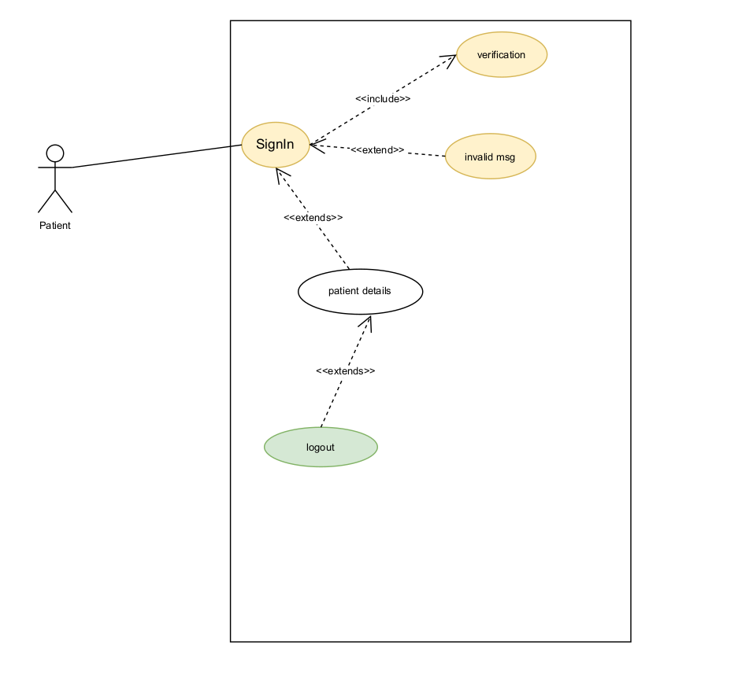Fig. 1

**| Use Case for Admin**:

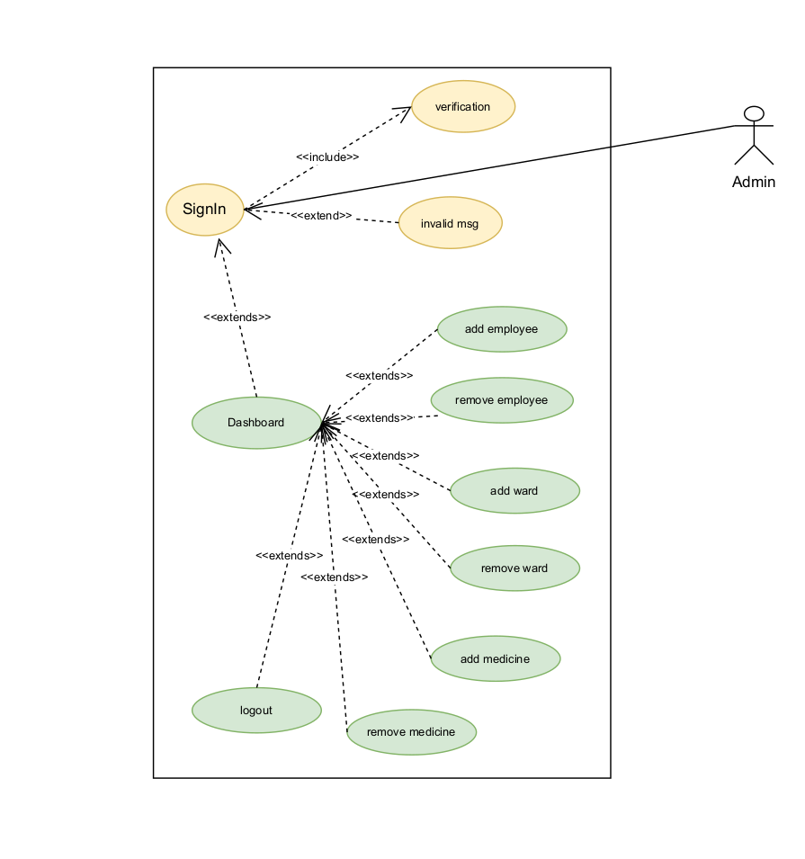Fig. 2

**Non - Functional Requirements**

**Usability Requirement:** Usability requirements are essential for ensuring that the Clinic Management System (CMS) is user-friendly, efficient, and effectively meets the needs of its users. These requirements guide the design and development process to create a system that enhances user satisfaction and productivity.

* User-Centered Design
* Intuitive Navigation
* Consistency
* Efficient Task Completion
* Accessibility
* Privacy and Data Security
* Collaboration and Communication
* User Training and Onboarding

**Data Model**

A data model is a visual representation of the structure, relationships, and constraints of the data that will be stored and managed by a system. In the context of a Clinic Management System (CMS), the data model outlines how different types of data are organized, connected, and stored within the system.

Entities:

* + Entities represent real-world objects or concepts that need to be stored and managed within the CMS. Examples include patients, healthcare providers, appointments, prescriptions, medical records, and billing information.

1. Attributes:
   * Attributes are characteristics or properties of entities. Each entity has a set of attributes that describe specific details. For example, a "Patient" entity might have attributes like "Name," "Date of Birth," "Contact Information," etc.
2. Relationships:
   * Relationships define how entities are related to each other. These relationships depict how data is connected within the system. Examples of relationships include "Patient has Appointments," "Doctor treats Patients," and "Prescription is for Patient."
3. Data Flow and Workflow:
   * The data model can also depict the flow of data and processes within the system, including how data moves between entities during different operations and workflows.

A well-designed data model is crucial for ensuring data accuracy, integrity, and efficiency within a Clinic Management System. It serves as the foundation for database design, informs software development, and enables effective data management and reporting.



Complete Database (fig 3)

**Screen Shots**

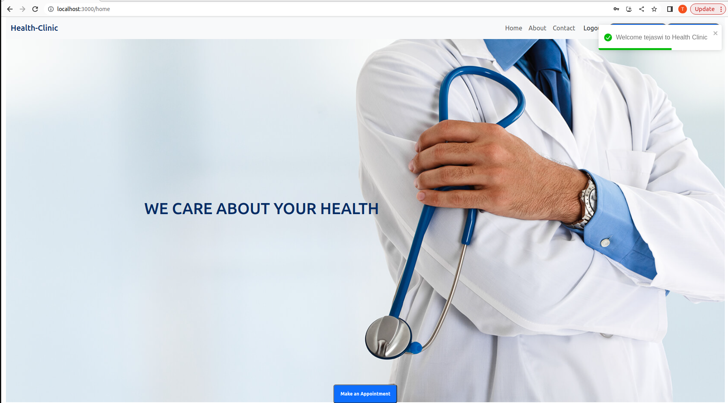

Fig. 4

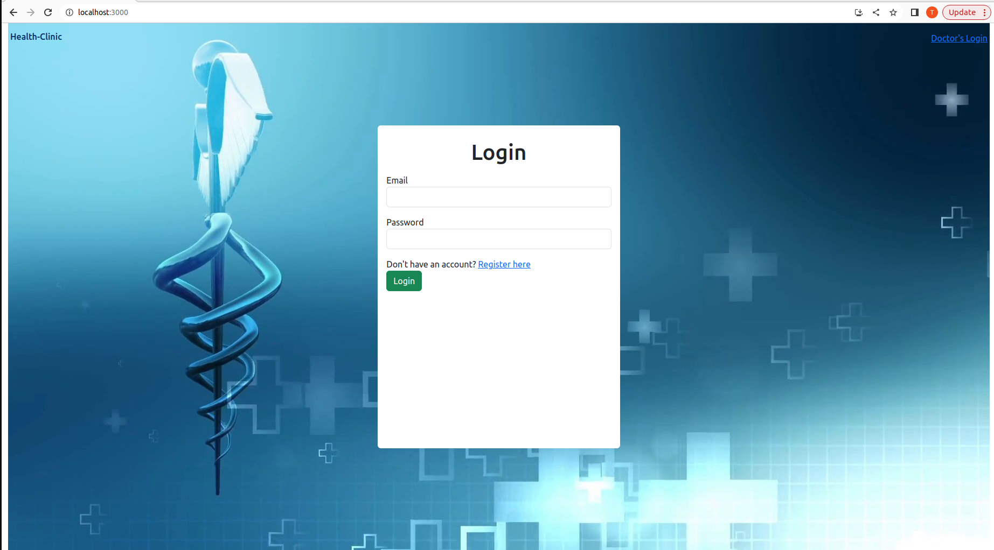

Fig. 5

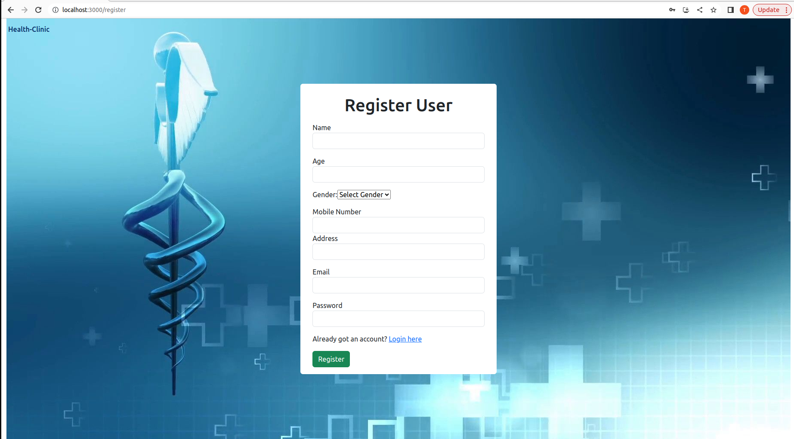

Fig. 6

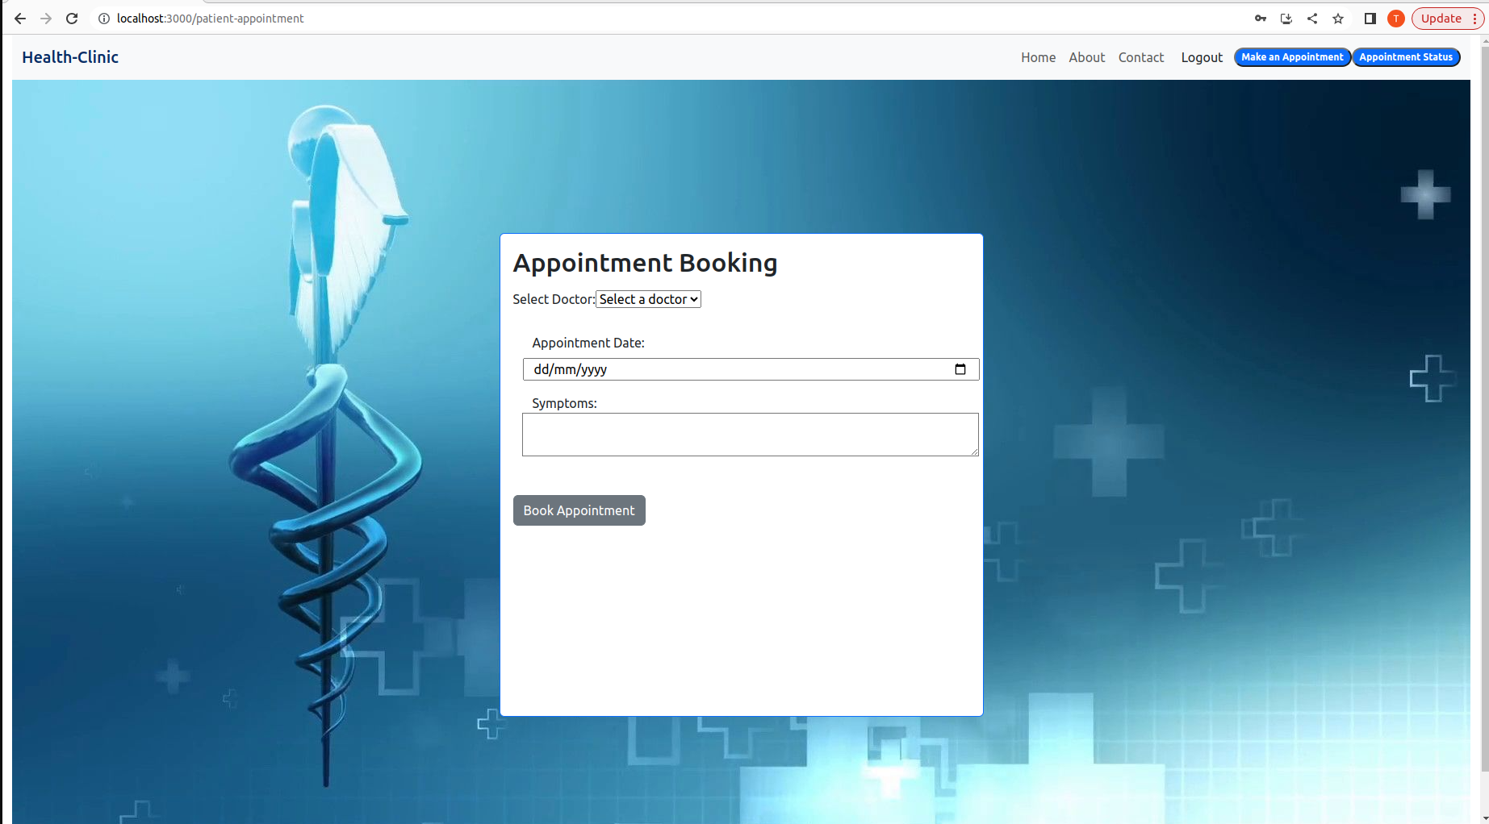

Fig. 7

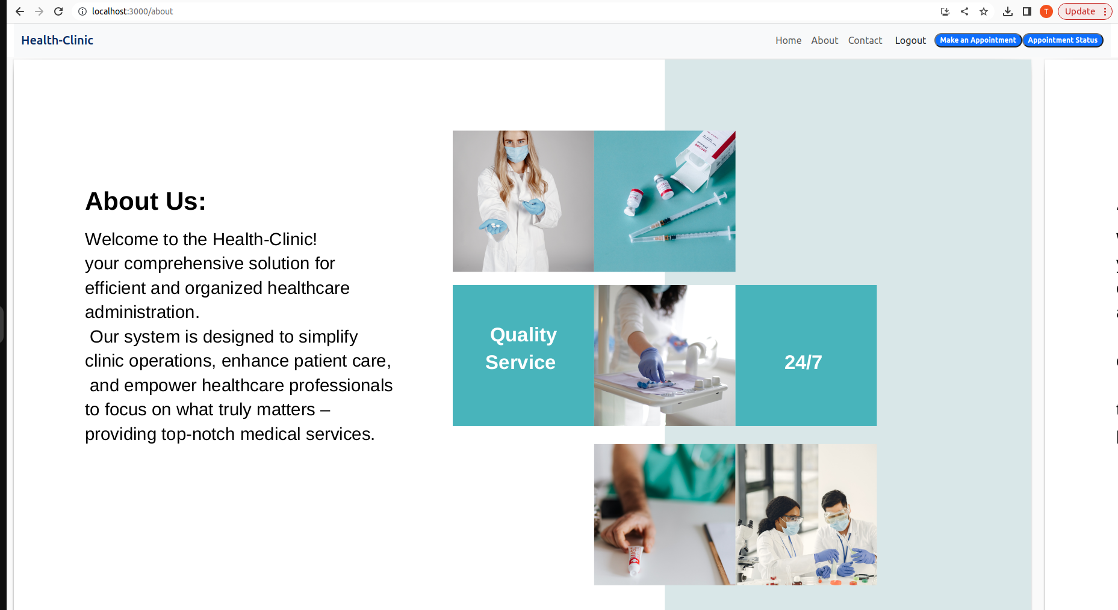

Fig. 8

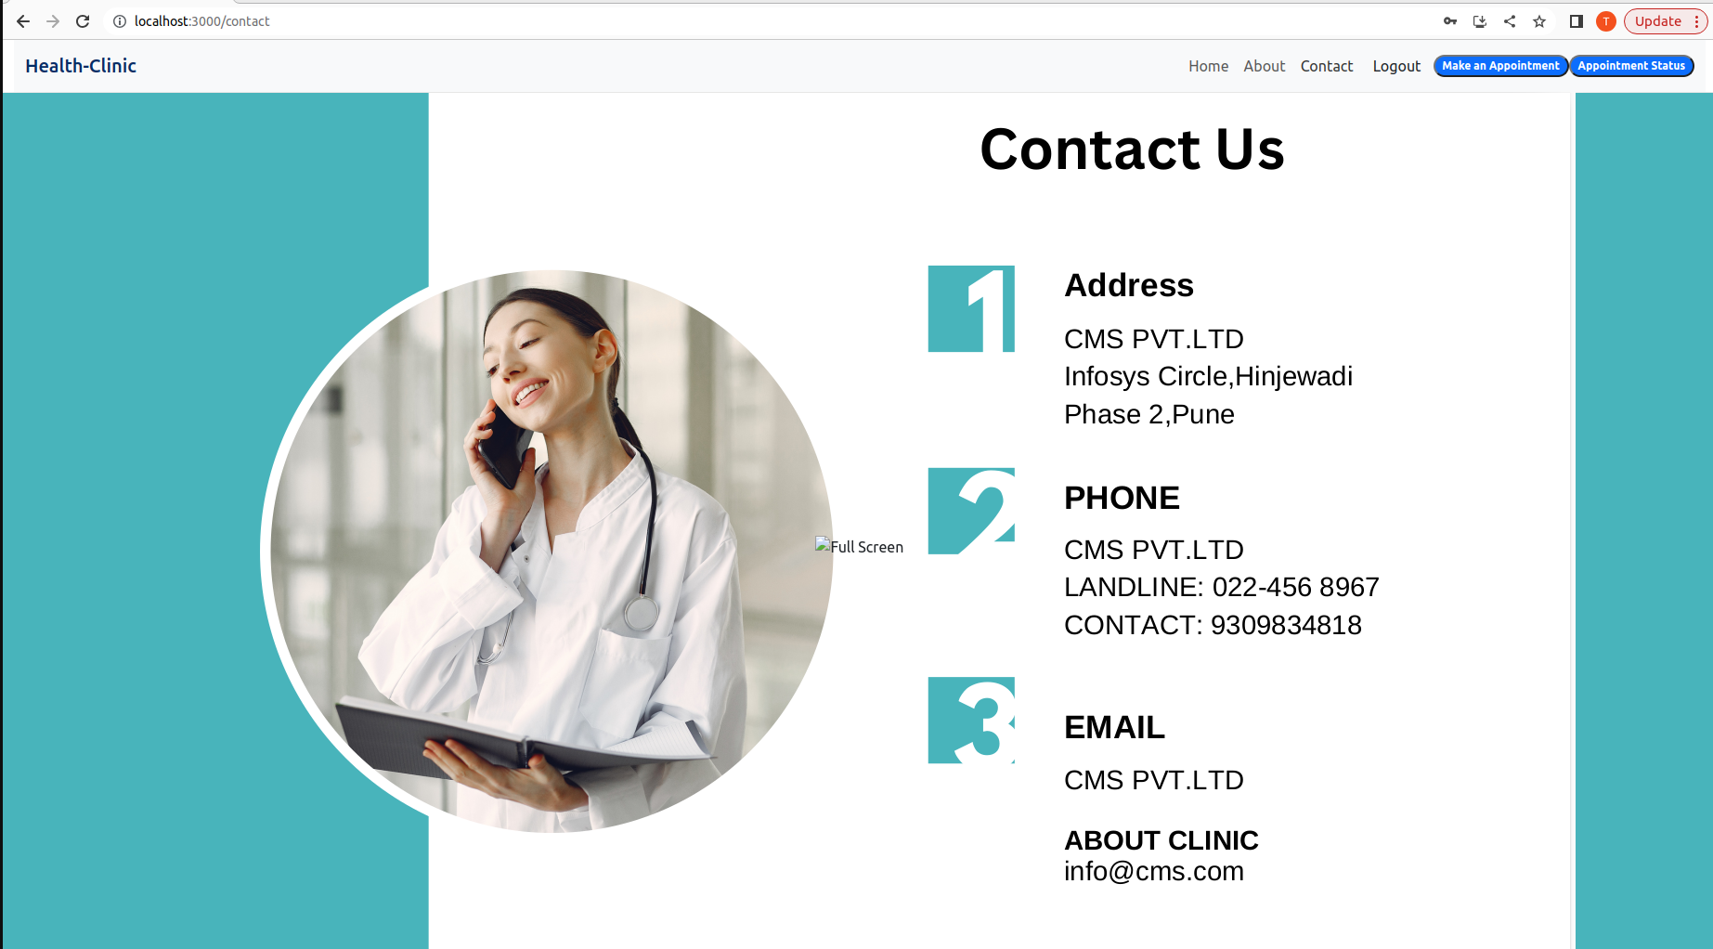

Fig. 9

**| Conclusion:**  A Clinic Management System (CMS) is a transformative solution that brings innovation to healthcare administration and patient care. As the healthcare industry evolves in the digital age, the CMS serves as a crucial tool for clinics and medical facilities to enhance efficiency, streamline operations, and deliver higher-quality services. Through this report, we've explored various aspects of the CMS, including its significance, functionalities, benefits, challenges, and user considerations.

The CMS addresses the complexities of clinic management by providing an integrated platform that manages patient information, appointment scheduling, electronic health records, prescriptions, billing, and reporting. This consolidation of functions not only simplifies administrative tasks but also empowers healthcare providers to focus on personalized patient care, leading to improved outcomes and experiences.

**| Future Work** : Future work in the realm of Clinic Management Systems (CMS) holds exciting potential for further innovation and improvement in healthcare operations and patient care. As the healthcare industry continues to evolve, here are some areas of future work and potential developments:

1. Enhanced Interoperability:
   * Future CMS solutions can focus on seamless integration with external systems, such as telemedicine platforms, wearable devices, and health monitoring tools. This enables a holistic view of patient health and facilitates remote patient monitoring.
2. Artificial Intelligence and Predictive Analytics:
   * AI-powered features like predictive analytics can help healthcare providers anticipate patient needs and trends, enabling proactive interventions and personalized treatment plans.

**| References:**

1. PubMed (<https://pubmed.ncbi.nlm.nih.gov/>): A widely-used database for medical research and healthcare-related articles.
2. IEEE Xplore (<https://ieeexplore.ieee.org/>): A database for scientific and technical literature, including articles on healthcare technology and systems.
3. ACM Digital Library (<https://dl.acm.org/>): A resource for research and literature in the field of computing, including healthcare informatics.
4. ScienceDirect (<https://www.sciencedirect.com/>): A platform that provides access to a wide range of scientific and medical research articles.
5. ResearchGate (<https://www.researchgate.net/>): A platform where researchers share their publications, including articles related to healthcare technology.
6. Healthcare IT News (<https://www.healthcareitnews.com/>): A news source that covers healthcare technology trends and developments.
7. HIMSS (Healthcare Information and Management Systems Society) (<https://www.himss.org/>): An organization that provides resources and information on healthcare information technology.